MA 2611 Lab 5

Xin Yu Wu

2024-10-04

**Problem L.17 and L.18*

#X ~ Normal(62,6.78)  
  
# a) P (52 ≤ X ≤ 56)  
ansA <- pnorm(56, 62, sqrt(6.78)) - pnorm(52, 62, sqrt(6.78))  
print(ansA)

## [1] 0.0105419

# b) P (X ≥ 75)  
ansB <- 1 - pnorm(75, 62, sqrt(6.78))  
print(ansB)

## [1] 2.978285e-07

# c) 10th percentile of X  
ansC <- qnorm(p=0.10,mean= 62,sd=sqrt(6.78))  
print(ansC)

## [1] 58.66304

# d) 95th percentile of X  
ansD <- qnorm(p=0.95,mean= 62,sd=sqrt(6.78))  
print(ansD)

## [1] 66.28294

**Problem L.19**

# a)  
  
ggplot(ChickWeight, aes(sample = weight)) +  
 geom_qq(colour = "sienna4", shape = 18, size = 2) +  
 geom_qq_line(colour = "deeppink2", linetype = "dashed", size = 1.5) +  
 labs(title = "Normal Q-Q Plot of Chick Weights",   
 x = "Theoretical Quantiles",  
 y = "Sample Quantiles")

## Warning: Using `size` aesthetic for lines was deprecated in ggplot2 3.4.0.  
## ℹ Please use `linewidth` instead.  
## This warning is displayed once every 8 hours.  
## Call `lifecycle::last_lifecycle_warnings()` to see where this warning was  
## generated.

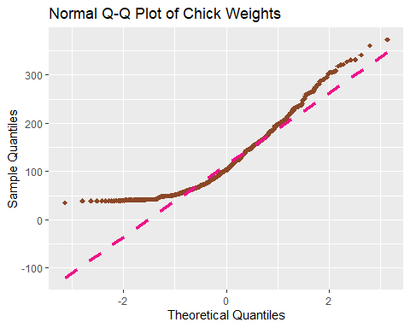

#ASK ABOUT GRAPH   
#b)  
ggplot(ChickWeight, aes(sample = weight, colour = Diet, shape = Diet)) +  
 geom_qq() +  
 geom_qq_line(colour="darkolivegreen") +  
 labs(title = "Grouped Normal Q-Q Plot of Chick Weights by Diet",   
 x = "Theoretical Quantiles",  
 y = "Sample Quantiles") +   
 scale_colour_manual(values=c("palevioletred","navajowhite2","dodgerblue","mediumspringgreen")) +  
 scale_shape_manual(values=c(25,8,1,10))

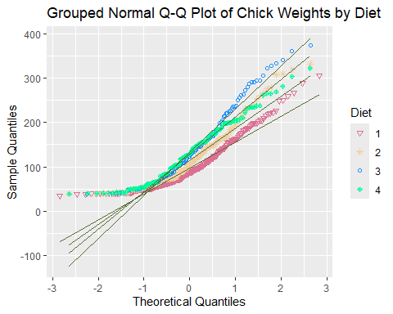 c) Comparing the plots in parts a and b, the weight dats seems to be normal distributed when grouped by data type, as shown by the differences between the data and normal distribution line. This indicates that when separated by diet type, the data continues to show a normal distribution. Moreober, when separated by data type, the normal distribution extends into higher quantiles.

**Problem L.20**

bagsWeights <- c(456.1, 454.9, 463.4, 454.4, 439.9, 439.4, 433.6, 454.4, 441.2, 451.7, 451.1, 454.1, 449.7, 450.1, 449.6, 449.8, 448.2, 451.5,  
447.9, 449.2, 455.1, 454.5, 459.2, 453.7, 456.5)  
  
#point estimate  
bagsweight_mean<-mean(bagsWeights)   
  
#multiplier  
bagsweight_mult <- qt(p=0.975, df=(length(bagsWeights) - 1))  
  
#standard error  
bagsweight_se <- sd(bagsWeights)/sqrt(length(bagsWeights))  
  
bagsWeight_upper <- bagsweight_mean + bagsweight_mult + bagsweight_se  
bagsWeight_upper

## [1] 454.1511

bagsWeight_lower <- bagsweight_mean - bagsweight_mult + bagsweight_se  
bagsWeight_lower

## [1] 450.0233

With 95% confidence interval [450.0, 454.2], the bags are packaged within the expected weight of 454 oz.

**Problem L.21**

successes <- 42   
n <- 568   
confidence_level <- 0.99   
  
# sample proportion  
p_hat <- 42 / 568  
  
# standard error  
se <- sqrt((p_hat * (1 - p_hat)) / 568)  
  
# z-score for the given confidence level  
z <- qnorm((1 - confidence_level) / 2, lower.tail = FALSE)  
  
# margin of error  
margin_of_error <- z * se  
  
# Calculate confidence interval  
lower_bound <- p_hat - margin_of_error  
upper_bound <- p_hat + margin_of_error  
  
print(p_hat)

## [1] 0.07394366

print(se)

## [1] 0.01097981

print(margin_of_error)

## [1] 0.02828213

print(lower_bound)

## [1] 0.04566153

print(upper_bound)

## [1] 0.1022258

With 99% confidence interval[ 0.04566153, 0.1022258], there might be some evidence to suggest a slight bias towards “lucky number” 7 because the upper bound, 0.1022, is above 0.05.However, we can’t conclude this definitely as 0.046 falls out of range/ is below 0.05.

```